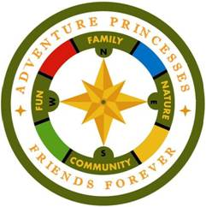
Newsletter Date
Volume 1, Issue 1

Kipoo Nation News

December 2014

A Newsletter of the Adventure Princess Program
http://daytonadventureprincess.com/
https://www.facebook.com/DaytonAdventurePrincesses
https://adventureprincesseskipoonation.shutterfly.com

Adventure Princess Fall Campout was another successful weekend in spite of rain, cold temperatures, and even a few snowflakes. Luckily the weather cleared up on Saturday so that the only white powder flying through the air was from the Flowerball fight.
The weather did not shy away dads and daughters from the all that Camp Kern has to offer, like fishing, climbing, archery, and BB Guns.
What girl doesn’t love to sing their favorite songs at the top of their lungs? This proved to be true at the Friday Night Scare-Karaoke. We had over 20 girls, and a few dads singing their favorite songs.
Several dads and daughters upheld the spirit of Halloween in costume.
The Fall campout proved to be one of the largest that we have taken to Camp Kern in recent Nation history. We bought 174 dads and daughters. The Adventure Princess Kipoo Nation was proud to welcome 27 new dad and daughter pairs to this event, also the largest new recruitment class in recent history.
Check out pictures a few pictures from our website of this event.

Upcoming Events
- December
Dad & Daughter Laser Tag

- January
Dad & Daughter Bowling

- February
Dad & Daughter Bowling

- March 7
Dad & Daughter Dance

- May
Spring Campout

The Kipoo Nation Welcomes 27 New Dads and Daughters!!

Ralph & C. Adkins
Matt & J. Andrews
David. & G. Baldetti
Mark & E. Becker
Vince & S. Dominic
Travis & H. Eggert
John & I. Ferrazza
Justin & H. Heil
Glenn & K. Hopper
Jimmy Hoshue
Rob & P. Ingle
Taurus & T. James
Travis & K. King
Chuck & S. Liebl
Don & T. Morrison
Matt & J. Nyikon
Ravi & S. Ramoo
Ernie & S. Riley
Fred & E. Schiller
Jason & C. Voorheis
Pete & A. Wagner
Eric & A Walker
Lewis & A. Lewis

Fall 2014 Campout Kern-o-Ween:

Scary, Cold, but Totally Fun!!

Just two weeks after the fall campout, the Trailblazer Tribe hosted the “Late Night Event & Pinewood Derby. Altogether 35 daughters and 10 dads raced cars in the Pinewood Derby. The dads and daughters also enjoyed swimming, gym activities, pizza, and, most of all, the fellowship of their fellow nation dads and daughters.
Check out a few pictures from our website of this event on our shutterfly page.
Morrison | T. | Trailblazers | 1st Grade | 1st Place
Eggert | H. | Phoenix | 1st Grade | 2nd Place
Militello | E. | Wallabies | 1st Grade | 3rd Place
Zimmerman | A. | Pioneers | 2nd Grade | 1st Place
Neilson | A. | Erie | 2nd Grade | 2nd Place
Springer | A. | Miami | 2nd Grade | 3rd Place
Youker | C. | Trailblazers | 3rd Grade | 1st Place
Dorko | L. | Phoenix | 3rd Grade | 2nd Place
Haley | A. | Phoenix | 3rd Grade | 3rd Place
Pitman | A. | Trailblazers | 4th Grade | 1st Place
Zeigler | E. | Phoenix | 4th Grade | 2nd Place
Andrews | I. | Discoverers | 4th Grade | 3rd Place
Wynn | L. | Wallabies | 5th Grade | 1st Place
Curran | L. | Erie | 5th Grade | 2nd Place
Carrera | M. | Miami | 5th Grade | 3rd Place
Culp | C. | Phoenix | 6th Grade | 1st Place
Warner | K. | Phoenix | 6th Grade | 2nd Place
Agulllera | D. | Miami | 6th Grade | 3rd Place
.

Fall 2014 - Late Night – Pinewood Derby

Adventure Princesses CANDLE SALE and Fundraiser.

Last year’s candle sale such a big success that we are doing them again. They make great gifts for the approaching Holiday Season. Similar Soy Candles would sell for about $39 in stores – save yourself $14 and SUPPORT TWO LOCAL ORGANIZATIONS at the same time!

As with last year, we’re asking for at least THREE candles to be sold by every daughter. Please promote the sale of candle rather than the buyout options for your Tribes. Here are a few highlights and some important info for this year’s sale program:
- Daughters selling 10 or more candles will receive a $100 bill at the Spring Campout (May 15-17, 2015)!
• Candles are $25 a piece and there are 3 fragrances to choose from.
• Candle buyout is $50 for one daughter and $70 for more than one daughter.
- Candles will be delivered in December.

Kipoo Nation Candle Sale

The Slogan, Purpose and Aims

What is the Purpose of the Y-Indian Princess Program?
To foster the understanding and companionship between father and daughter

What is the Slogan of the Y-Indian Princess Program?
Friends Always!

What are the SIX AIMS the Y-Indian Princess Program?
To be clean in body and pure in heart
To be friends always with my father
To listen while others speak
To love the sacred circle of my family
To love my neighbor as myself
To seek and preserve the beauty of the Great Spirit's work in forest, field, and stream

The memories of an exciting camp-out, Father-Daughter Dance, or any Nation activity can now be safely shared throughout our organization. We have created a photo sharing site through shutterfly.
Just go to the following address:
https://adventureprincesseskipoonation.shutterfly.com
You do not need an account.
This website is password protected with our Indian word for “Amen” that looks like: “N*****y”.
This protection will allow only Kipoo Nation members to access this photo site. Everyone with this password is welcome to upload or download photos.
https://adventureprincesseskipoonation.shutterfly.com/

Kipoo Nation Photo Sharing Site

Princesses, what is your favorite Adventure Princess Memory?

Princesses, would you like to a favorite memory to the Kipoo Nation News? Allison Kline wrote about her favorite Adventure Princess memory in the essay below. Contact your Tribe Chief if you too would like to submit your own favorite memory essay.

What I Love about the Adventure Princess Program: by Allison Kline
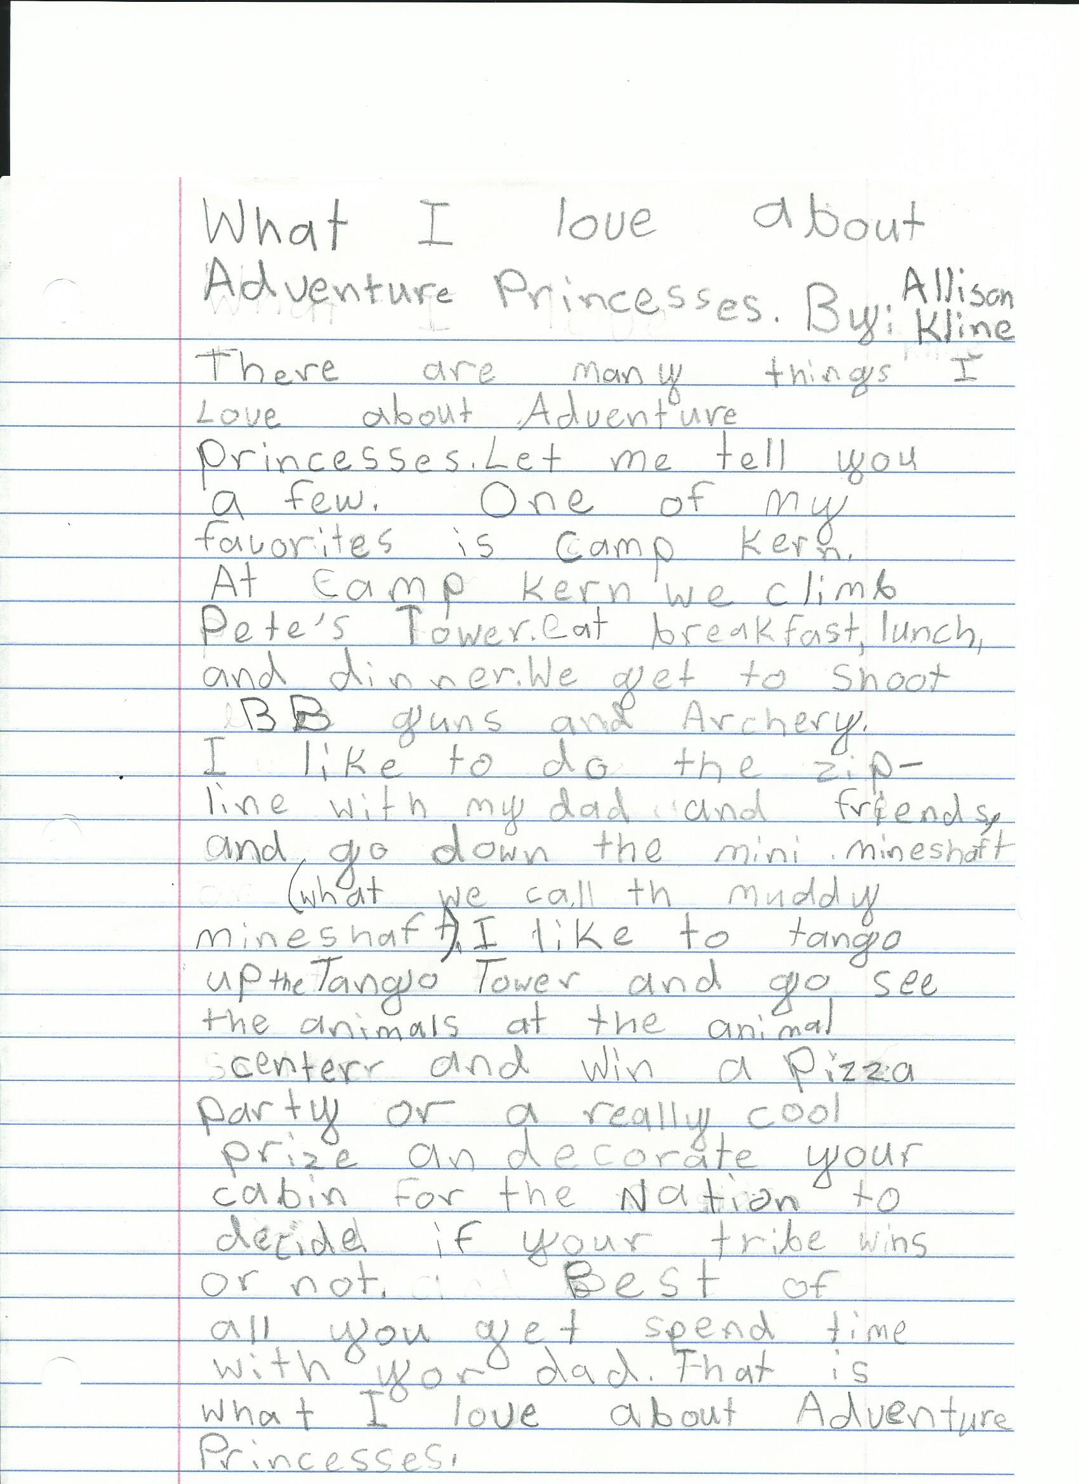
Service Awards:
The following Daughters completed Service Awards and received a Service Patch at the Fall Campout
C. Culp Phoenix Tribe Collected food for the homeless shelter
K. Warner Phoenix Tribe Volunteered at the Young’s Dairy Charity Ride
H. Eggert Phoenix Tribe Took part in the Weller Clean-Up
T. James Trailblazer Tribe Volunteered at the Food Bank
A. Pitman Trailblazer Tribe Volunteered at Bogg Ministries Food Pantry

Adventure Princesses

Kipoo Nation Upcoming Events

Tribe Meeting Schedule
Discoverers | First Wednesday of the month @ 7:00 PM
Erie | First Wednesday of the month @ 7:00 PM
Miami | Second Thursday of the month @ 7:00 PM
Phoenix | Second Tuesday of the month @ 7:00 PM
Pioneers | First Thursday of the month @ 7:00 PM
Trailblazers | Second Thursday of the month @ 6:30 PM
Wallabies | Second Tuesday of the month @ 7:00 PM

Dad & Daughter Laser Tag December 13th@10am Hosted By: Discoverers
Dad & Daughter Bowling January 17th@12:30 Hosted By: Erie
UD Women’s Basketball February 15th Hosted By: Phoenix
Father Daughter Dance March 7th Hosted By: Wallabies
Spring Campout May 15th-17th Hosted By: Erie & Phoenix

Adventure Princesses
Kipoo NAtion
South Ymca
4545 South Marshall Rd.
Kettering, OH 45429

